**Basics of Object Detection**

**1. Definitions and Key Concepts**

- **Object Detection**: A process used in computer vision to identify and locate objects in an image or video using bounding boxes and labels.

- **Bounding Box**: A rectangular outline drawn around an object to highlight its position in the image.

- **Confidence Score**: A value between 0 and 1 that indicates how certain the model is about its prediction.

- **Intersection over Union (IoU)**: A metric to evaluate the overlap between the predicted bounding box and the actual object to measure accuracy.

- **Annotation**: The process of labeling images with object names and bounding boxes, often used to train models.

- **R-CNN (Region-based Convolutional Neural Network)**: An object detection model that extracts multiple regions from an image and processes each through a neural network. There are more advanced algorithms based on this model e.g. Fast R-CNN, and Faster R-CNN.

- **SSD (Single Shot Detector)**: A faster algorithm that detects objects in a single step, useful for real-time detection.

- **Mean Average Percentage:** Used to evaluate object detection accuracy of predicted bounding boxes

- **YOLO (You Only Look Once)**: A fast and efficient object detection algorithm that divides the image into a grid and predicts objects in one pass.

**2. Steps of Object Detection**

1. **Load Image**: Provide an input image for the model.

2. **Pre-process Image**: Resize and normalize the image for the model.

3. **Run Detection Model**: Use algorithms like YOLO or SSD to detect objects.

4. **Output Results**: The model draws bounding boxes and provides confidence scores for each object.

5. **Post-Processing**: Filter out low-confidence results and adjust boxes if needed.

**3. Overview of Tools and Libraries**

1. **TensorFlow**: A machine learning library used to create and train object detection models.

• **Installation**: Run pip install tensorflow.

2. **Keras**: A neural network library that simplifies model building, running on top of TensorFlow.

• **Installation**: Keras is included in TensorFlow; no extra installation needed.

3. **OpenCV**: A library used for image processing and computer vision tasks like object detection.

• **Installation**: Run pip install OpenCV-python.

**4. Common Challenges and Troubleshooting Tips**

1. **Low Detection Accuracy**:

• Solution: Use more annotated training data or try a different algorithm like YOLOv5.

2. **Slow Model Performance**:

• Solution: Use SSD or YOLO for real-time detection instead of R-CNN.

3. **Model Overfitting**:

• Solution: Use data augmentation (e.g., flipping, rotating images).

**5. Additional Resources**

• TensorFlow Object Detection Documentation: [https://www.tensorflow.org](https://www.tensorflow.org/)

• OpenCV Tutorials: [https://opencv.org](https://opencv.org/)

• “Deep Learning with Python” by François Chollet

Object detection with YOLO5 & Python incorporated: <https://www.youtube.com/watch?v=fu2tfOV9vbY&pp=ygUQb2JqZWN0IGRldGVjdGlvbg%3D%3D>

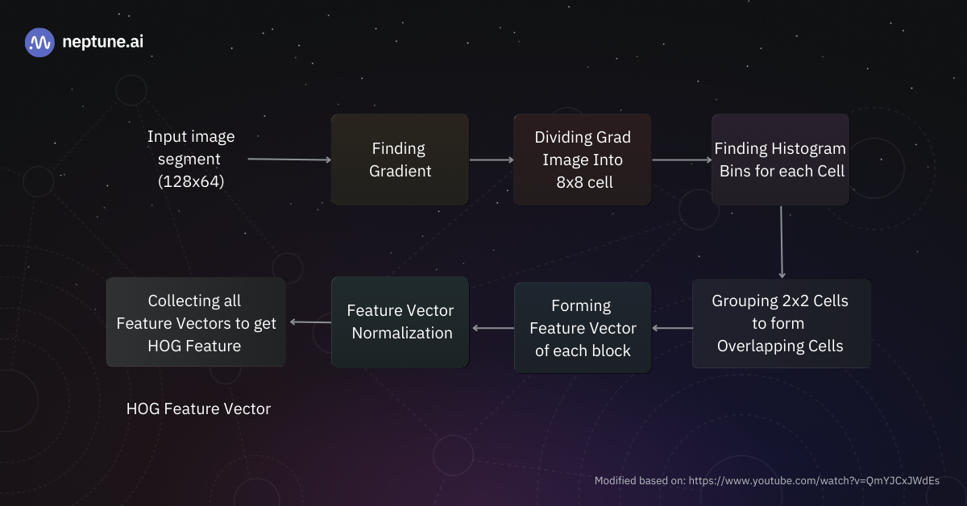Object Detection Architecture ("Object Detection Algorithms and Libraries: A Comprehensive Guide.")

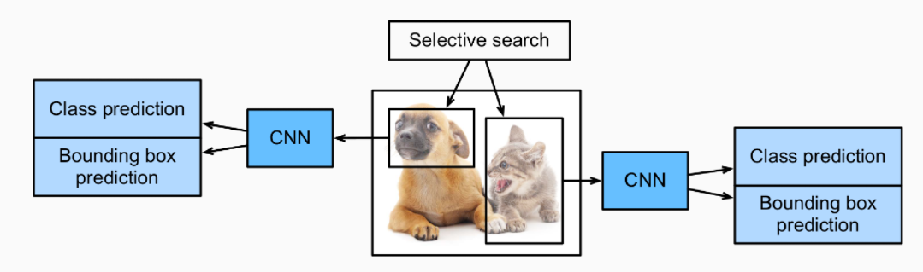R-CNN Process ("Object Detection Algorithms and Libraries: A Comprehensive Guide.")

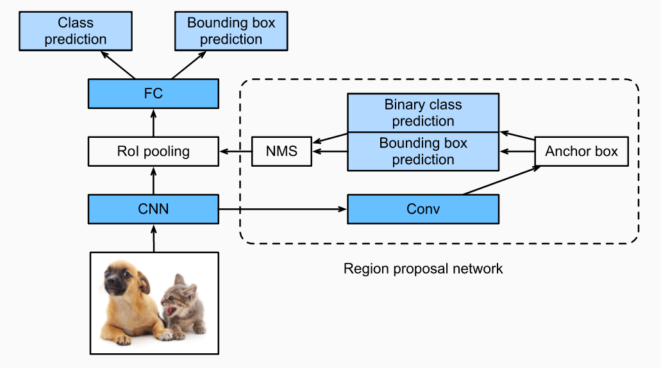Faster R-CNN ("Object Detection Algorithms and Libraries: A Comprehensive Guide.")

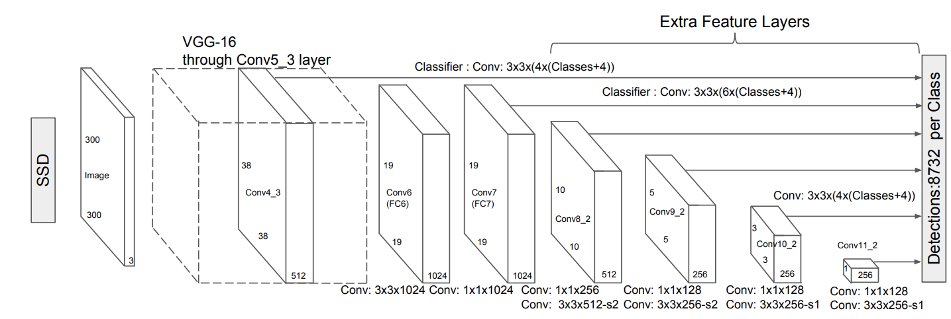Single Shot Detector ("Object Detection Algorithms and Libraries: A Comprehensive Guide.")

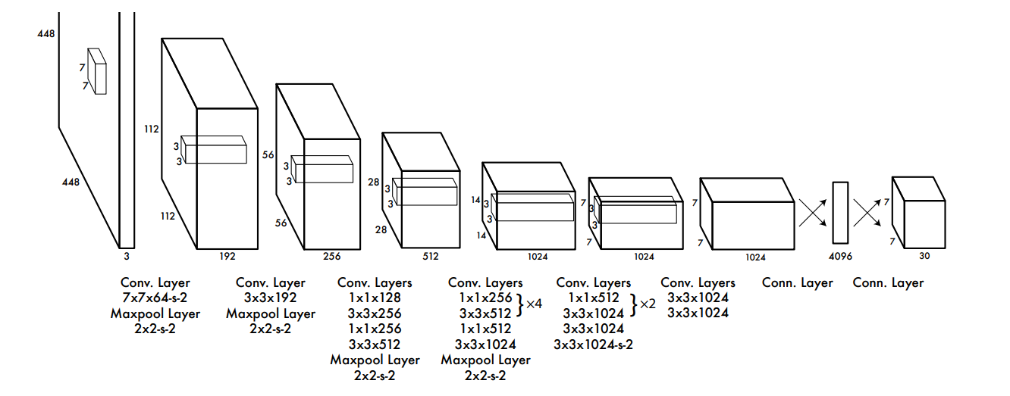Working Process of YOLO ("Object Detection Algorithms and Libraries: A Comprehensive Guide.")

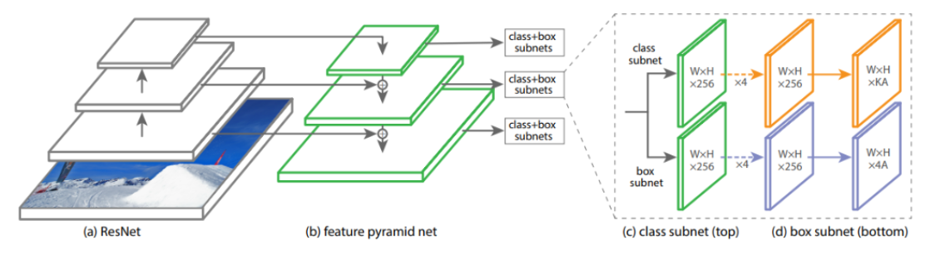RetinaNEt ("Object Detection Algorithms and Libraries: A Comprehensive Guide.")

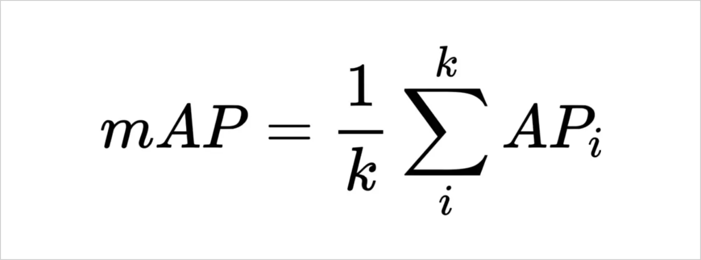Mean Average Precision ("Mean Average Precision and Its Uses in Object Detection.")

**Reflection**

In this assignment, we learned about the importance of object detection in computer vision and how different algorithms like YOLO, SSD, and R-CNN work to detect objects efficiently. I now understand key concepts such as bounding boxes, IoU, and confidence scores. Exploring tools like TensorFlow, Keras, and OpenCV helped me see how these libraries simplify building and using object detection models. I also found it useful to learn troubleshooting tips, such as how to address low accuracy or slow model performance. This cheat sheet will serve as a helpful reference for future tasks, allowing me to quickly recall essential concepts and tools related to object detection.

Reflection:

In this lab, we explored object detection and analyzed its key concepts and applications to understand their importance in computer vision. We also gained an understanding of how deep learning models such as YOLO, R-CNN, and SSD and their overall utilization to perform object detection. I learned that object detection is used to identify and locate objects in videos and images by displaying bounding boxes to verify the location within the photo, which in return produces a confidence score to determine a validity percentage. What intrigued me the most was the actual object detection process and how a computer can be trained simply from overloading images to comprehend an object’s position within a picture. As a team, we even discussed the real-world applications of this technology, such as how it can be used for items like security cameras. We also discussed how Tesla uses this technology in their electric vehicles to assist drivers. We also explored the various libraries such as TensorFlow, Keras, and OpenCV and how they are necessary to perform object detection tasks. I was also fascinated by the troubleshooting tips on ways to make the model perform efficiently in the event it does not function properly such as having to use a different algorithm or having to feed the model more data. I was interested because I can imagine how long the process can take to train a model from scratch. This cheat sheet is essential because I can always refer to it to stay informed about object detection concepts, processes, and applications. Overall, my team was able to gain a general understanding of object detection and its process. (Jonathan)

Exploring this assignment, I was able to dive deeper into object detection. I was able to explore and define the differences between the different methods of object detection. These methods are used for different circumstances to make a situation faster and more efficient to resolve the conflict. I also was able to distinguish the steps to object detection in a model to successfully detect the right objects the model was given as the task. Then from there I compared the different tools used to complete the assessments for these models. Depending on the method used, each is used for the same goal but interacts differently based on the model or challenge it is given. This cheat sheet will benefit me for future object detection tasks because it gives me the freedom to go back and review each concept and see the connection to the task I am working on. This is very convenient because a lot of the times when I am confused it is likely I would go to the browser to search up what I am looking for, yet I still need to make the connection to the assignment. This cheat sheet allows me to directly see the concept for what it is because the connection is already there because it is very well for the same class, so everything was done before hand.

**Works Cited**

Wiatr, Piotr. "Object Detection Algorithms and Libraries: A Comprehensive Guide." *Neptune.ai*, 26 Sept. 2023, https://neptune.ai/blog/object-detection-algorithms-and-libraries. Accessed 23 Oct. 2024.

"Object Detection." *YouTube*, uploaded by Nicholas Renotte, 2 Mar. 2023, https://www.youtube.com/watch?v=fu2tfOV9vbY. Accessed 23 Oct. 2024.

"TensorFlow." *TensorFlow*, Google, https://www.tensorflow.org/. Accessed 24 Oct. 2024.

"Mean Average Precision and Its Uses in Object Detection." *SuperAnnotate*, 19 Apr. 2023, https://www.superannotate.com/blog/mean-average-precision-and-its-uses-in-object-detection. Accessed 24 Oct. 2024.